Anthony Bollella 3/31/14
Lee Fothergill Coordinating
Geogebra Lesson: Understanding Geometry Translations; Reflections, Rotations, Translations.
Grades: 8-10
- Open up Geogebra and open up the grid by holding down CTRL and RIGHT CLICK and click on GRID.
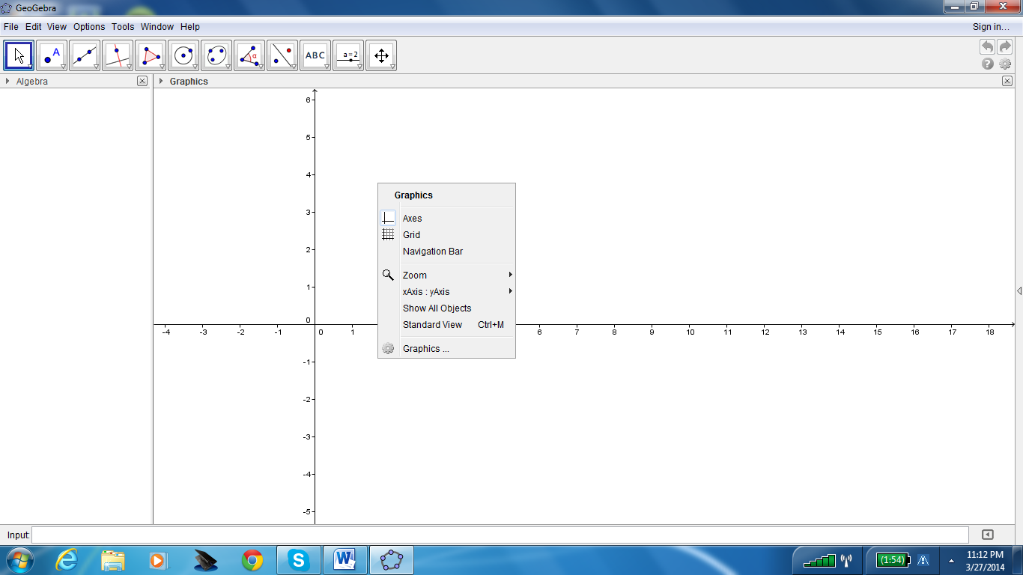
Then click on the icon that says POLYGON and input the points A= (1, 1), B= (2, 3), and C (5, 2) to form a triangle.

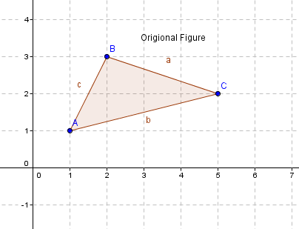

- Then after connecting points A, B, C, label the figure by going to the icon that says TEXT and label it original figure then press OK.

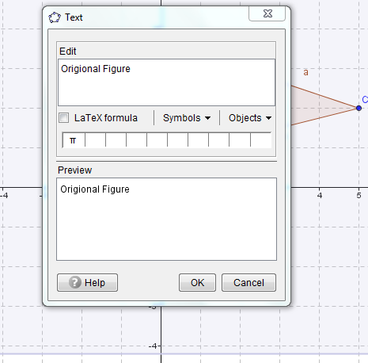

- Once you have labeled your picture you then can go ahead and reflect Triangle ABC along the x-axis first. Click on the icon that says REFLECT ALONG LINE and then highlight the triangle and click the x-axis and it will reflect. Once reflecting over the x-axis you will get D= (1, -1) E= (2, -3) F= (5, -2). After you reflect it you can then label it Reflection over x-axis.
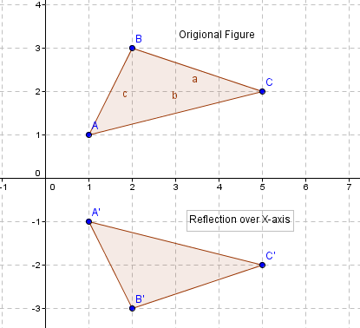
Draw some conclusions:
- What would happen when you reflect over the x-axis?
(x,y) (___,____)

- After reflecting over the x-axis, then reflect over the y-axis, which you will then have to negate the x- coordinate only, so again click the REFLECT OVER LINE icon and highlight the triangle and press the y-axis line and reflect it. G= (-1, 1) H= (-2, 3) I= (-5, 2).
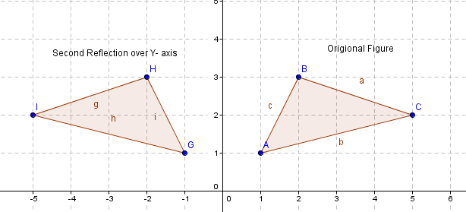
- What would happen when reflecting over y- axis?
(x,y) (____,____)

On your own: Reflect over line y=x. __________
(x,y) (____,____)

Once you reflect the Triangle ABC over the x and y axes your diagram should look like this:
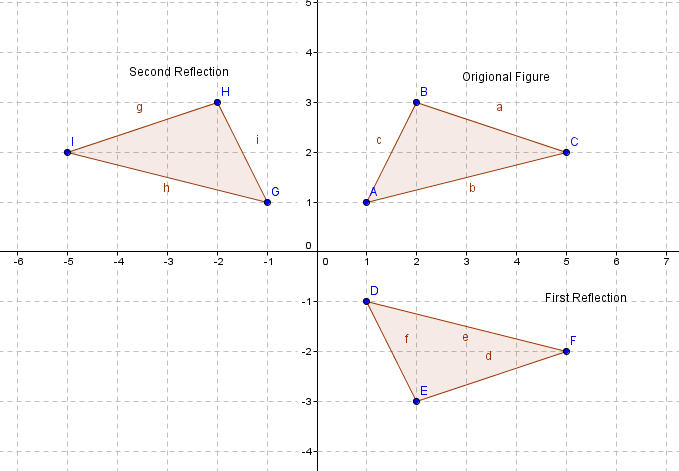

- Keep the original triangle ABC with the same points from before and now we want to rotate the triangle about a point say D (6, -2).
- Go to the icon where you can reflect about a point or line and click on ROTATE AROUND POINT, then click on the triangle and then point D and the screen below will pop up.
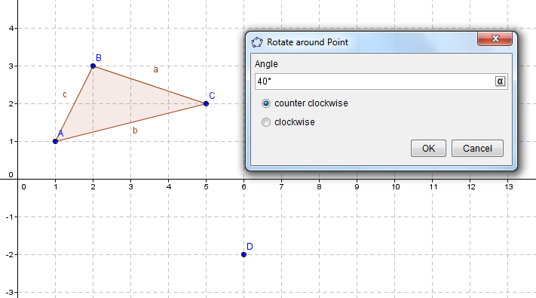
- When the screen above pops up change it to 90 degrees and counterclockwise then click OK. You can see the triangle ABC is rotated about point D 90 degrees counterclockwise.
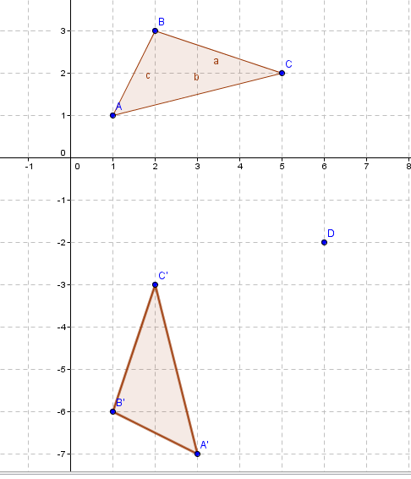
Some other examples you may want to try for fun would be rotating along some different points and see what you can find:
- Rotating 180 degrees clockwise. _____________
- Rotating 270 degrees counterclockwise. _______________

- Point (0, 0)
- Next we will want to Translate triangle ABC along the x and y axes. Create triangle ABC same as before and go to the icon REFLECT BY LINE from before but click on TRANSLATE BY VECTOR. Once you have clicked on that click on point D = (4, -1). You will then move the line created over to E= (-1, 0) and click.

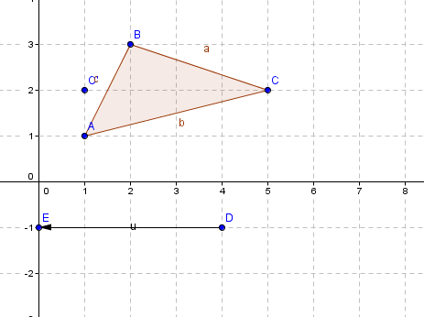

- Once that is complete you can see that triangle ABC has shifted 4 units to the left horizontally.
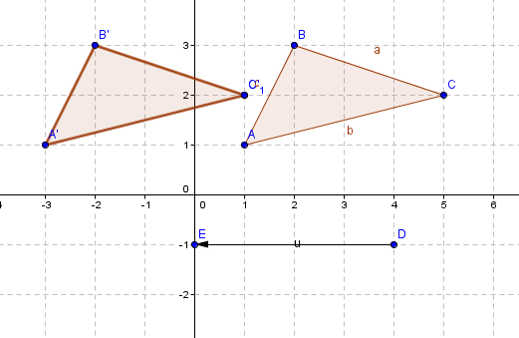
- Keep triangle ABC and now translate 4 units down vertically. Go to TRANSLATE BY VECTOR again and from point D= (6, 1), and click on the triangle and then point D and drag it down to point E = (6, -3).
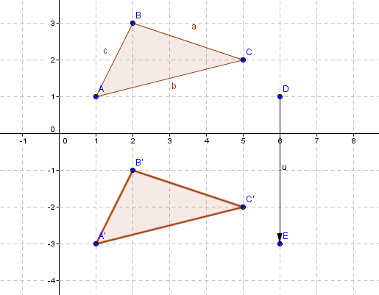
Now try some examples translating triangle ABC:
- V= $〈-2,2〉$ __________.
- V=$〈-3,-2〉$ __________.
- V= $〈4,4〉$__________.
- Now we want to dilate triangle ABC from a point say D which will be (-1, 1).

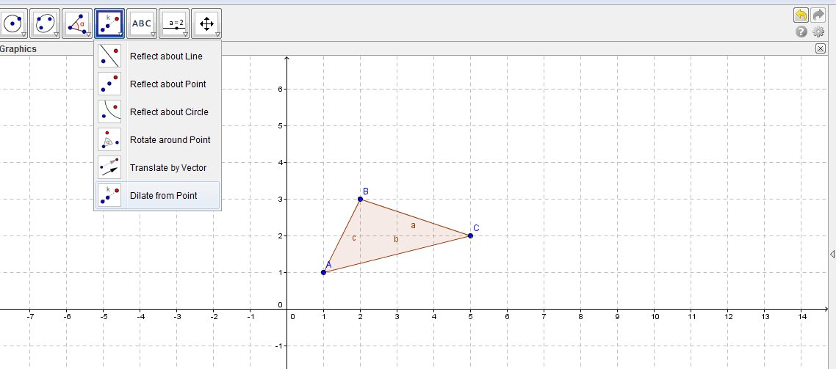
We know the rule for dilating a shape is D_{k} (x, y) = (kx, ky). This means whatever factor you make K is what you multiply x and y by. Once you have clicked on DILATE FROM A POINT, click on the triangle and then point D and a box will come up asking to input the factor…
- When this box appears input 2 and you will see the coordinates of triangle ABC will be multiplied by 2 and Triangle ABC’ will be shown by dilating by 2 from point (1, -1).

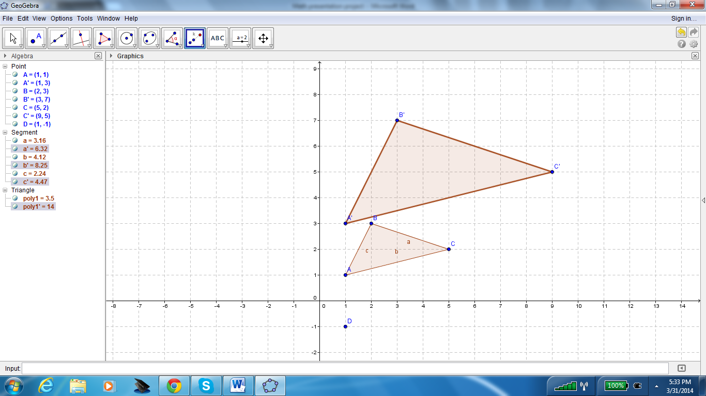

- Dilate triangle ABC by 3.___________
- Dilate triangle ABC by 4.___________

